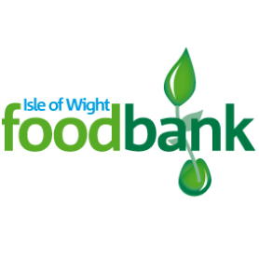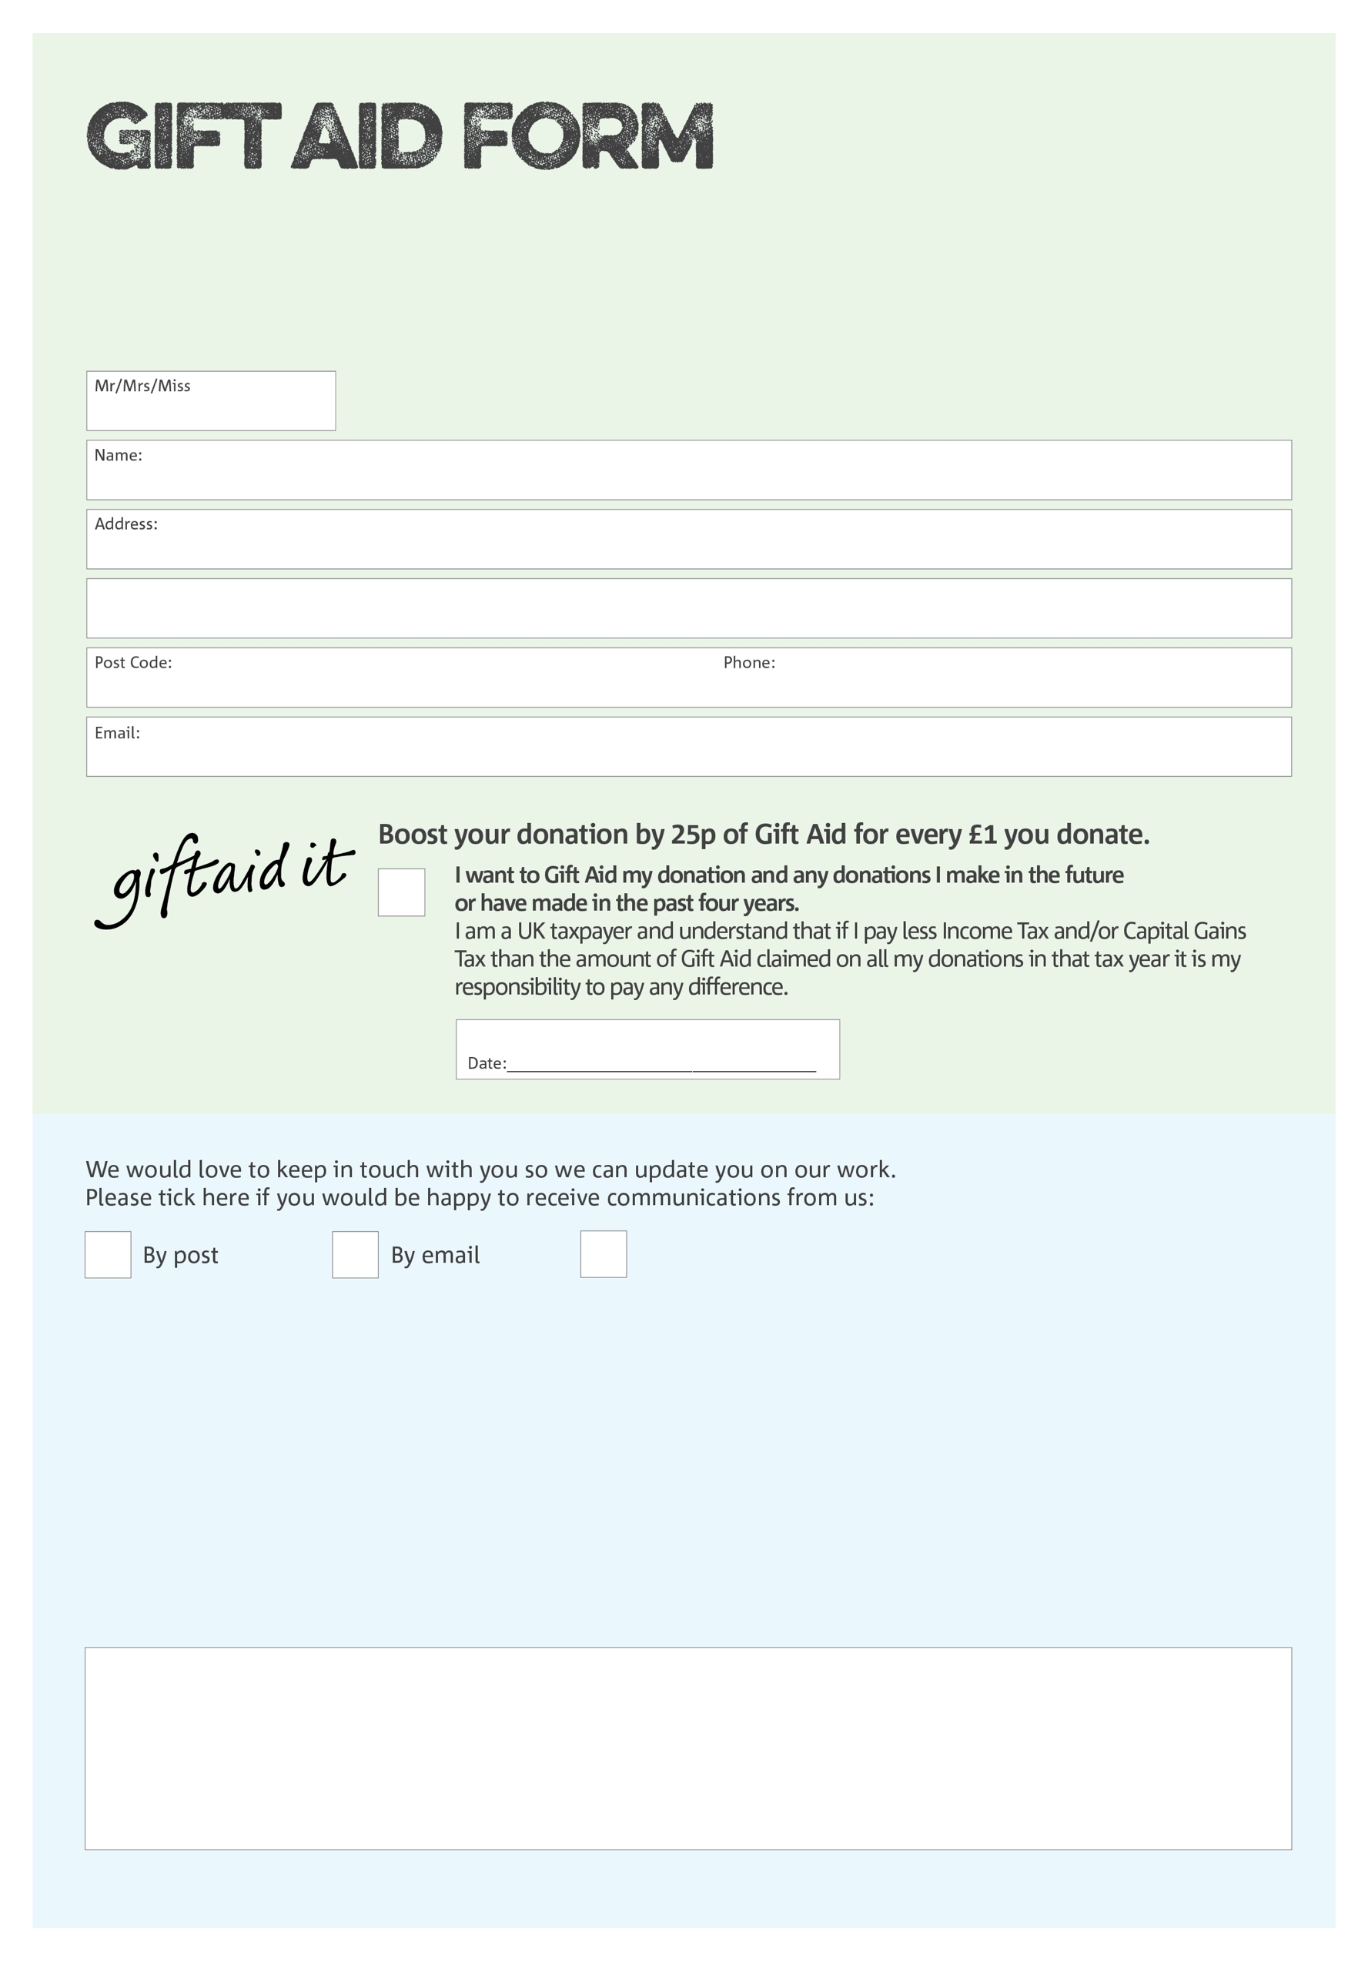

By filling in this form the Isle of Wight Foodbank will receive an extra 25p for every £1 you give at no extra cost to you. Thank you!

**Data protection**

*The Isle of Wight Foodbank is committed to protecting your privacy and will process your personal data in accordance with current Data Protection legislation. The Isle of Wight Foodbank collects information to keep in touch with you and supply you with information relating to our work. To unsubscribe from our newsletter, send a message to the email address above with the word unsubscribe in the subject line. A full data privacy statement for financial donors is available from the foodbank on request.*

You can change your preferences any time by contacting us on 01983 292040 or emailing us at

info@isleofwight.foodbank.org.uk

I do not wish to receive future communications from Isle of Wight Foodbank

We would love to know why you have chosen to donate to the Isle of Wight Foodbank. If you would like to share your motivation let us know below:

Registered Charity No: 1144644 Reg in Eng. & Wales